CERTIFICATION INDIVIDUAL OR COMPANY
NOT CURRENTLY ENGAGED IN A BOYCOTT OF ISRAEL

In accordance with HB 2409, 2017 Legislative Session, the State of Kansas shall not enter into a contract with any Individual or Company to acquire or dispose of services, supplies, information technology or construction, unless such Individual or Company submits a written certification that such Individual or Company is not currently engaged in a boycott of Israel.

As an Individual or Contractor entering into a contract with the State of Kansas, it is hereby certified that the Individual or Company listed below is not currently engaged in a boycott of Israel.

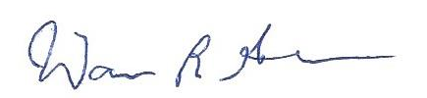
____________________________________________ _______________________
Signature, Title of Contractor Date

____________________________________________
Printed

____________________________________________
Name of Company

